Through the Ages Vassal Starter Doc

1. Download and install the most recent Vassal engine and then download the TTA module (no need to install the module, just drop it in a folder). As of 3/14/09, the current Vassal engine is 3.1.0 at http://www.vassalengine.org/forums/viewtopic.php?t=1715 and the current TTA module is 2.46 at http://www.mediafire.com/?sharekey=49f566963eac526791b20cc0d07ba4d208fd0801551ae382 If the links don't work, you can visit the vassal site and find the download at http://www.vassalengine.org

2. Open Vassal. (if it is not setup with the Wizard you get the below screen shot.)
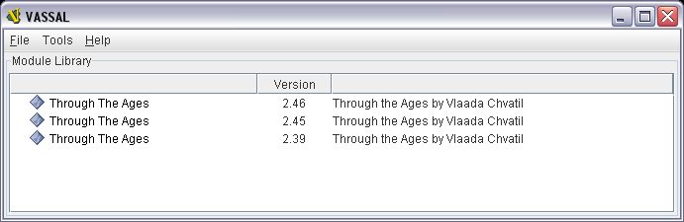

Use File -> Open Module to load a module for the first time, or just double click on your already loaded. Once you start a game under a particular revision, you have to play the whole game under that version as they aren't compatible. Using the most recent version is typically the best.

3. Through the Ages module then opens with the below control window screen shot
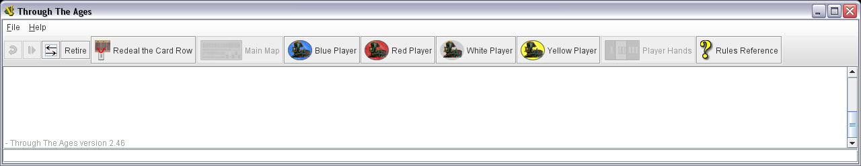

Typically File-> Preferences I have set are:
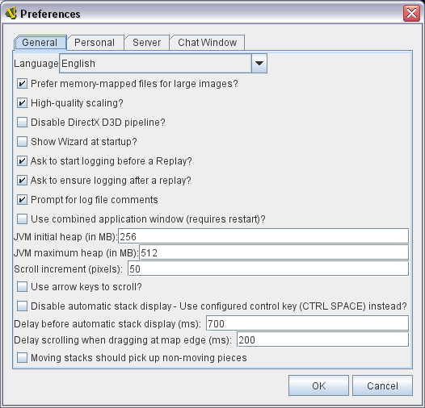

Use File -> Load Game to load in a log file from your opponent. (or New Game, if you are starting new and select the appropriate number of players.) Could take a minute or so to load, depending on your PC speed. In a New Game, the first player right clicks and selects the First Player card which then automatically populates the Military deck. Then they can then Redeal the Card Row.

4. Choose your color
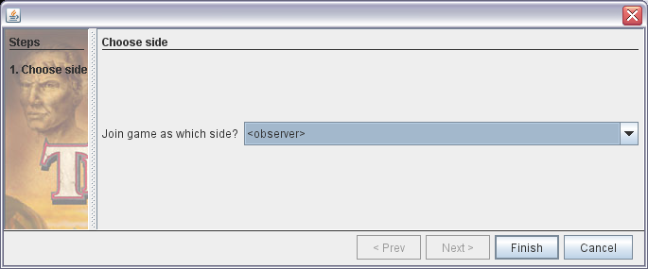

5. If it asks to start a new Logfile, you can say no at this point if it is not a New Game, since you need to step through your opponents moves first. To do that continually hit the play button to step through their moves. Sometimes it can be useful to first click on the Main Map button so you can see the map and/or their Player civilization so you can read and watch the moves. Resize the screens as necessary.
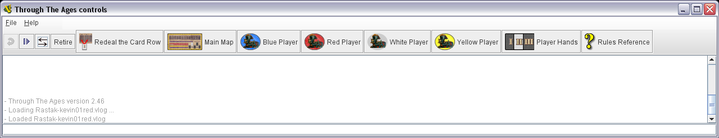

6. As you step through their turn, their moves will be automatically popped up in the text in purple. They can type in comments in the box below the text, and it shows up in black. Notice after the comment, you see the End of Turn Sequence notes, I will explain those below..
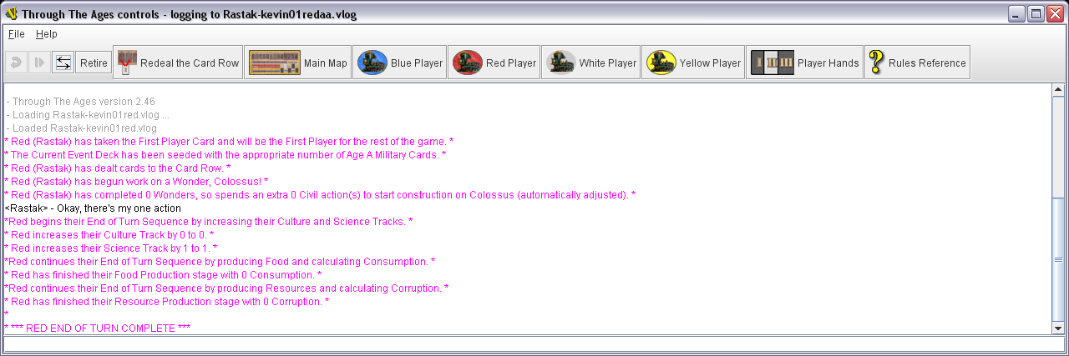

7. Now that you stepped through all your opponents moves it is time to start a New Logfile. Use the same naming convention as the previous and just update your color and/or turn counter in file name.
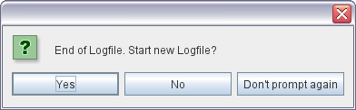

8. Now that you have your log file open, it is time to perform your turn. Open your card hand and civilization boards by left clicking your "color" player and selecting. This will open up a card hand window and your civilization window. Here are a bunch of how to's:

**Political Phase**: First thing you need to do is play or pass on a military card political play and discard down to your military card hand limit if necessary (unless it is the setup/1st turn). You can move your cards around in the card hand window to see them all by expanding the window and left click drag-n-dropping the cards. Remember to adjust strength used in colonizing, etc.. before playing a political card so any automatic effects register correctly if they pertain to most strength nation. Manually adjust items which aren't automatically adjusted by the political event. Typically the card mentions if it is manual or auto. You can drag/drop military cards from the main map board into your card window if particular events call for players to get X amount of military cards.

Main Board Cards : Right click -> Add card to Hand from the main map board to select a card from the card row. Your government civil actions will automatically decrement the appropriate amount. It also takes into account 2nd, 3rd, etc… extra costs for wonders. You must manually adjust any leader bonuses for pulling cards such as Aristotle.

Cards in Hand: Right click -> Put Card into Play. Civil or military actions automatically deduced. If playing a yellow card, the action won't deduct till you perform the associated other action. Any technology costs will automatically be deducted from your technology total. Any blue token mine/farm resource costs need to be spent manually by left clicking on the blue tokens.

Adjust +'s : If playing cards gives you more strength or culture/technology +'s you must manually adjust those charts before you perform your end turn sequence. Just right click on the appropriate chart on the main map and add (or subtract) the specific number of points. For small increments you can click on you civilization map at the top to add/subtract 1 at a time with the black arrows.

Building : Right click on a card and select the appropriate menu item to build. You must manually spend the blue resources by just left clicking the blue resource from the appropriate mine(s). One gets removed each click. Remember to manually adjust charts if necessary.

Increase Population : Right click inside the Yellow bank to increase/decrease population (which moves them into the population box) or adjust happiness, make a pop a discontented worker instead (or just remember it from your pop box) and add/subtract yellow tokens due to events or end of an age. You must manually spend the blue resources to pay for the population increases.

Blue token Add/Subtract : Right click inside the Blue bank to add/remove blue tokens due to colonies, blue special card plays, events, etc…
Fixing Civil/Military actions: Right click on your government card to add/remove civil/military actions which might be needed due to spending less actions due to technology cards you have (masonry, etc…) or leaders which give action discounts.

Wonders : Some wonders automatically add their special ability, others don't. Just confirm your stats after playing them. For the ocean liner left click on the wonder to add the extra population.

Culture Adjustments : You can right on the 0 on the main board culture map to adjust up/down event card culture changes which do not automatically get applied or by playing Age III wonders.

Military/Colonies : If colonies pop up or Military aggressions/wars occur, it is typical to just email your opponent what card popped up and how much strength you will be using. They can open their previous log file to see the board if they need to and reply in email with a bid raise/pass. Repeat email replies till the high bid is established, at which point the current player can finish their turn, adjusting their military appropriately if they won. (Right click colony -> Add to civ, adjust tokens manually) If another person won, before they start their turn by playing a political card, they need add the civ and spend the appropriate military and adjust their nation strength. In a multiplayer game, have the winner perform a short add civ & military adjustment turn and log file save and email.

End of Turn Process : Once you have used all your civil and/or military actions do the following steps to wrap up your turn:

1. Confirm your Technology and Culture +'s and Military track charts are correct. Also make sure your military actions remaining are correct. (since you will get X military cards based on that)
2. Make sure you are on your color civilization map (else it will apply to another color), then:
a) Left click End of Turn Process -> select 1. Production of Science and Culture
b) Left click End of Turn Process -> select 2. Food Production and Consumption (remove the amount of food resources as indicated in the pop up box manually from the appropriate farm(s))
c) Left click End of Turn Process -> select 3. Production of Resources and Corruption (remove the amount of mine resources as indicated in the pop up box manually from the appropriate mine(s))
3. Click on Redeal the Card Row on the main control window to replenish the main map card row. (If this causes the Age to end, perform the End of Age process below)
4. File -> End Logfile to save your log file of moves.
5. Email that Logfile to your opponent.

End of Age Process : When the last civil action card is put into the card row, the end of an age occurs. Do the following steps at that point:

1. Right click inside each player's yellow bank and remove 2 yellow tokens.
2. Go to your card hand window and Right click -> Discard any cards two ages back.
3. Right click current Military deck -> Remove Deck from the board.
4. Right click the appropriate next Age Civil cards at bottom of board -> Send to Civil Deck
5. Right click the appropriate next Age Military cards at bottom of the board -> Send to Military Deck
6. If there are open spots at the end of the main card row: Drag/drop via left click a civil card into each open spot.
7. Write a comment reminding your opponent(s) to remove any twice old Age cards in their hands. You can see the Age types of cards in players hands from the control window->Player Hands button.
Solo Play : You can choose to play the game solo too. Use the control window -> Retire button to flip between player colors.

